644/1284 Narrow

User's manual

Presentation of the board 2
Board specifications 3
Pinout 4
Installation 5
CH340 driver 5
Arduino environment 5
Board definition / MigthyCore 6
IDE configuration when using the MightyCore 7
Programming 8
SPI programming 8
USB programming 8
Programming examples 9
Blink 9
2nd Serial port 9
0.49” OLED display 9

Presentation of the board

644 Narrow and 1284 Narrow were inspired by the Arduino Nano board. Their functionality is quite the same but instead of featuring an Atmega328 MCU they implement an Atmega644 or Atmega1284.

These boards are as small as possible, to fit on a breadboard, given that they feature an MCU, a USB plug, a USB/Serial converter, an ISP port, an I2C port, a power circuit and a couple of LEDs. In addition to a usual layout you will find on the board a special I2C port (GND-5V-SCL-SDA) where you can solder a 0.49” OLED display.

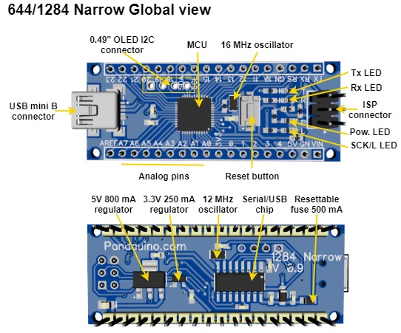

As compared to the Nano and Uno board they feature:

- 4kb/16kb instead of 2 Kb of RAM
- 64kb/128kb instead of 32 Kb of Flash memory
- 2Kb/4Kb instead of 1 Kb of EEPROM
- One more USART port
- 12 more digital I/O

Even though the line of product is different they remain part of the latest 8 bits MCU from Atmel with quite the same architecture as that of the Atmega328. So if you are familiar with the Atmega328 based boards you will have no problem using those boards. Programming in the Arduino environment is the same.

You can download the Atmega644/1284 data sheet from this link

Board specifications
 | 644 Narrow | 1284 Narrow
MCU | Atmega644pa-mu | Atmega1284p-mu
Operating voltage | 5V, with on board 5V and 3.3V regulators. | 5V, with on board 5V and 3.3V regulators.
Max current | USB: 500 mA limited by a PTC. Vin: 800 mA @ 6.2V, 25°c | USB: 500 mA limited by a PTC. Vin: 800 mA @ 6.2V, 25°c
Flash | 64 Kb | 128 Kb
RAM | 4 Kb | 16 Kb
EEPROM | 2 Kb | 4 Kb
Digital I/Os | 24 | 24
Analog I/Os | 8 | 8
PWM | 6 | 8
SPI | 1 | 1
USART | 2 | 2
I2C | 1 | 1
USB | 1 | 1
Size | 1097 mm² | 1097 mm²
Weight | 8 g | 8 g

Pinout

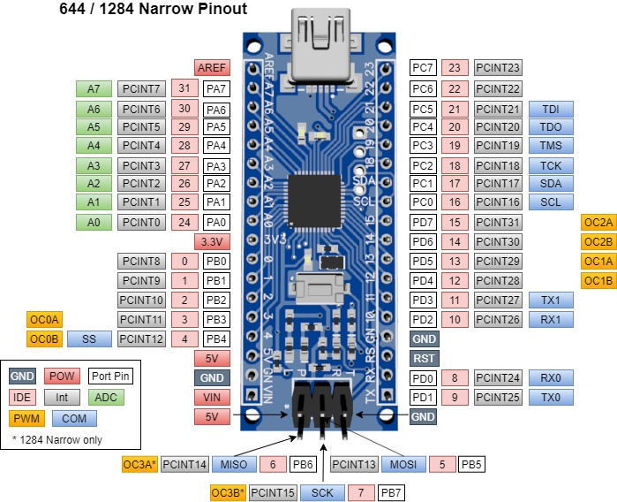

Installation

CH340 driver

The USB/Serial adapter is the well know CH340G chip. It is a Chinese chip that is implemented on most Nano clones and works well.

You will need to install its driver from http://www.wch.cn/download/CH341SER_EXE.html but the page is mostly in Chinese language.

You can also refer to https://sparks.gogo.co.nz/ch340.html

Once the driver is installed and you connect the board to your computer using a USB plug you should see it listed in the USB peripherals with a name like “CH340”

Arduino environment

Of course if you intend to develop your program in the Arduino Environment you must have the Arduino IDE installed. You can download it from https://www.arduino.cc/en/main/software

Board definition / MigthyCore

The Arduino IDE does not include the Atmega644 and Atmega1284 support by default. You can find a couple of boards definitions on github see

https://github.com/search?q=Atmega644
https://github.com/search?q=Atmega1284

But you will probably like the MightyCore.

Install the MighyCore

Follow the installation process: https://github.com/MCUdude/MightyCore#how-to-install.

If you already have mighyCore installed, it is best to unsintall it, delete the package (see below) and do a fresh install of version 2.0.5 minimum.

Replace the boards.txt file

Then make you should replace or modify the boards.txt to include the Narrow boards.

First you need to know where your Arduino packages are installed. For example on Windows 10 the Arduino package root is usually under
C:\Users\_YOUR_USER_NAME_\AppData\Local\Arduino15\packages

Arduino installed the MightyCore in this directory. Now move to the subdirectory

\MightyCore\hardware\avr\2.0.5

and replace (after storing a copy) the file boards.txt with the one downloaded from
https://github.com/mrguen/644-1284-Narrow/blob/master/boards.txt

The only difference is the addition of these lines in the # Pinouts sections of the ATmega1284/P and ATmega644/A/P/PA sections of this file:

644.menu.pinout. narrow =Narrow pinout
644.menu.pinout. narrow.build.variant=standard
644.menu.pinout. narrow.build.bootloader_led=B7

1284.menu.pinout.narrow=Narrow pinout
1284.menu.pinout.narrow.build.variant=standard
1284.menu.pinout.narrow.build.bootloader_led=B7

This allows the Arduino IDE to define the builtin_led so it will select the appropriate bootloader.

IDE configuration when using the MightyCore

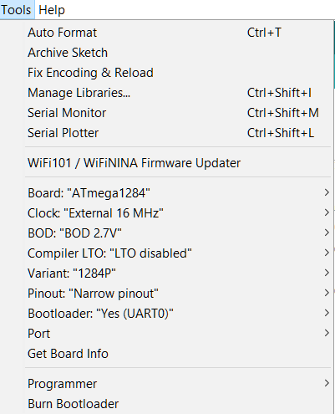
In the Arduino IDE Tools menu, you should select these options:

Board: Atmega644 or Atmega1284

Clock: External 16 MHz

BOD: BOD 2.7V

Compiler LTO: disabled but you can also use LTO enabled

Variant: P or PA variant

Pinout: Narrow Pinout

Bootloader: Yes (UART0)

Port: the COM port given by your system (once the bootloader has been installed and the board connected through the USB port)

Programming

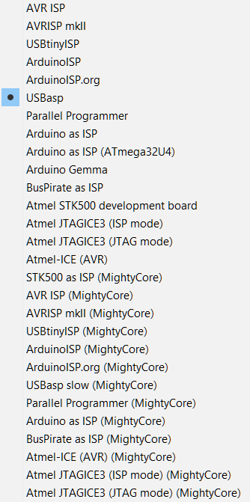
SPI programming

You can program the board using a programmer like the USBAsp or any of the many other supported programmers.

- Install your programmer on your system
- Connect the programmer to the ISP port (2*3 header) on the device and to the computer. It should be properly listed as a device by your system.
- Select the proper programmer in Tools/Programmer
- Select the menu Sketch/Upload Using Programmer. If this fails check step 2

USB programming

When the bootloader is installed, you can also program the device through a USB port and communicate with it using the Serial Monitor.

The bootloader has been uploaded on the device already but it might have been written over.

To burn the bootloader, just upload it to the board with a programmer (see steps 1-3 of SPI programming) by selecting the menu Tools/Burn Bootloader.

To upload your code you can simply press the arrow button in the main window of the Arduino IDE or the menu Sketch/Upload

Programming examples

Blink
Usually you might want to check that everything is working properly by programming the sketch Blink.ino that you will find in the Arduino IDE menu Files/Examples/Basic/Blink

The led labelled “L” on the board will be blinking at low speed.

If id does not, check that you have defined the board as explained in Board definition / MigthyCore

2nd Serial port

This board has two serial ports.

1) You can test that they are working using the sketch that you will find int the Arduino IDE menu File/Examples/Communication/MultiSerial

This sketch needs to have a serial device attached to the Serial 1 port (pin 10 RX1, pin 11 TX1).

2) If you don’t have such a device you can simply try this sketch

https://github.com/mrguen/644-1284-Narrow/tree/master/examples/Endless_Serial_0_1/Endless_Serial_0_1.ino/

Connect pins TX and 10 together.

Program the sketch through the USB port. In the Serial Monitor, if you type a letter to send to the board through the Serial port, it will display endlessly on the screen because it is sent back by serial “0” Tx pin to the serial monitor and also to serial “1” Rx, that writes again to serial “0” Tx.

0.49” OLED display

There is a group of four plated through-holes on the board to solder a tiny 0.49” OLED 64x32 pixels display. Not all I2C OLED modules connections are arranged in the same order so check it before soldering in your display. These holes are connected to

GND – 5V – SCL - SDA

Attention: the labels SDA and SCL on the board are for the pins on the edge of the board and not for this connector that has SCL and SDA arranged the other way and that are not labelled.

There are three examples available.

1) Using the Adafruit libraries
https://github.com/mrguen/644-1284-Narrow/tree/master/examples/test_SSD1306_Adafruit

The Adafruit library is mostly interesting is you want to display shapes, or even bitmaps. See https://learn.adafruit.com/adafruit-gfx-graphics-library

2) Using the Greiman library
https://github.com/mrguen/644-1284-Narrow/tree/master/examples/test_SSD1306_Ascii

Initially based on https://github.com/greiman/SSD1306Ascii library, it is mostly limited to text rendering but with a large and nice choice of fonts.

3) Using the ST7789_Fast by library by cbm80amiga
https://github.com/cbm80amiga/Arduino_ST7789_Fast

This will allow you to fast draw heavy bitmaps. See the example
https://github.com/mrguen/644-1284-Narrow/tree/master/examples/Graphicstest_ST7789_Fast_Narrow_TFT_240x240_balloon

